PARVEZ -- 31-07-2024 -- BASH SCRIPTING

Created a bash script for checking the file exist or not

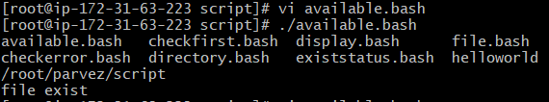

Created multiple file

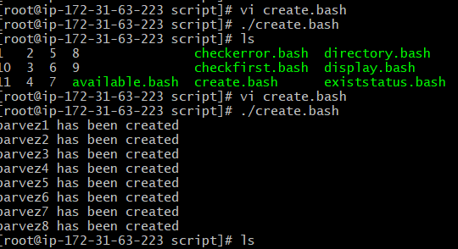

Created a backup of directory

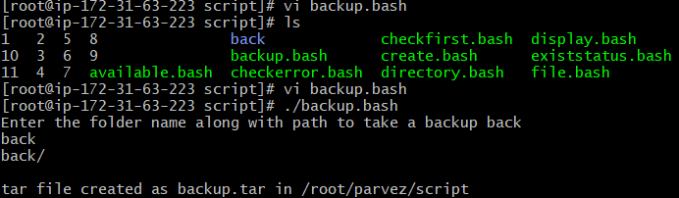

Created a bash script and download the nginx

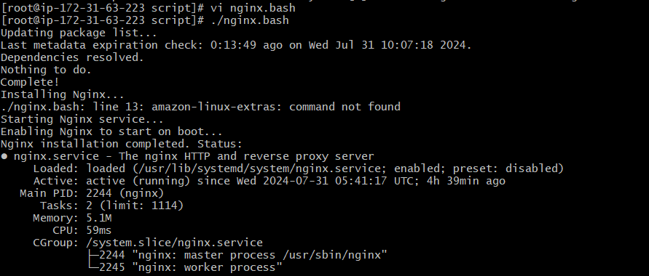

Create a bash script to check list if nginx service is running or not, if not running then script should start the service.

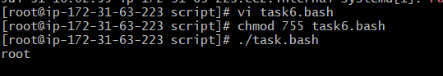

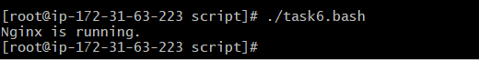

Created a bash script for calculator

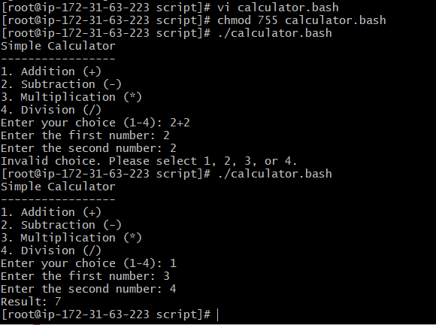

Created a bash script to check if directory is available or not, if not then create a directory.

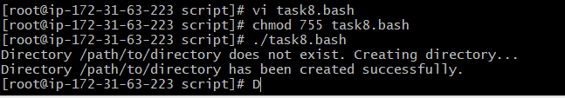

Created a bash script to delete last 3lines of a script

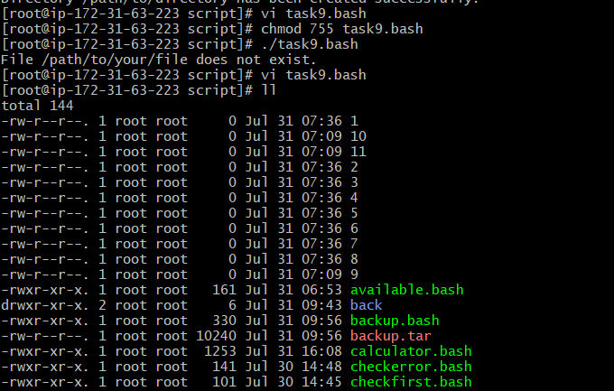

Crontab exercise

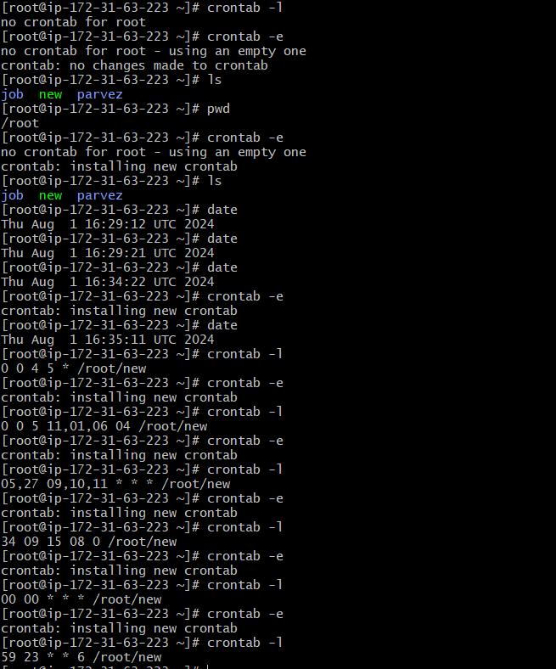

Push the file to github repository

